|  |  |
| --- | --- |
| http://paperpkblog.com/admissions/wp-content/uploads/2015/05/Jobs-in-Foundation-University-Islamabad-FUI-20141.jpg | **FOUNDATION UNIVERSITY ISLAMABAD** |

**Baker’s ERP**

***Submitted by***

F17BCSE015 – HAMMAD AHMAD

F17BCSE027 – HAMMAD QASIR

F17BCSE029 – MAKHDOOM HASNAIN

F17BCSE051 –TAFOOR AHMED

**BACHELORS**

**IN**

**COMPUTER SOFTWARE ENGINEERING**

**YEAR**

**2017-2021**

***Project Advisor***

M.WAQAS AHMED

COORDINATOR NAME

Submitted to the Department of Software Engineering of Foundation University Islamabad, in partial fulfillment for the requirements of a Bachelor of Computer Degree in Software Engineering

**DEDICATION**

We dedicate this project to the teachers who helped us through out 4 years and also to the panel,Supervisor because of them this project has been completed .

**ACKNOWLEDGEMENTS**

We would like to thanks our teachers. A special gratitude we give to our final year project supervisor, MR WAQAS AHMED ,whose contribution in stimulating suggestions and encouragement, helped us to coordinate our project especially in writing this report.

Furthermore we would also like to acknowledge with much appreciation the crucial role of the staff of Foundation University , who gave the permission to use all required equipment and the necessary materials to complete the tasks. Last but not least, many thanks go to the head of the project,MR WAQAS AHMED and MR ISHTIQ AHMED they both invested their full effort in guiding the team in achieving the goal .We have to appreciate the guidance given by other supervisor as well as the panels especially in our project presentation that has improved our presentation skills thanks to their comment and advice (MR.ISHTIAQ, MS .ASMA NAVEED, DR. TEHMINA KIRAMAT).

**STATEMENT OF ORIGINALITY**

We namely **-HAMMAD AHMAD, --HAMMAD QASIR , MAKHDOOM HASNAIN -----, and --TAFOOR AHMED ----------, s**ubmitting thesis titled “**----Baker’s ERP---------------------------------------------------------------------**”. State that we clearly understand what plagiarism is and we have also read about it using online sources. As such, we claim that this entire work (code, reports etc.) is our own effort. We have not used/copy or pasted or paraphrased even a single line of code or sentence from any other source without giving a proper reference to it. Based on our confidence in our originality, we allow the University to run anti-plagiarism software on the same.

We understand that if now, or in the future, ever it is found out that we have not been honest and have plagiarized, the university will take action and will result in disciplinary action, such as the cancellation of our degree and we can be liable for any subsequent punishments as deemed appropriate by the University as well as the Higher Education Commission Pakistan.

[Signature and date]

[Name]

[Signature and date]

[Name]

[Signature and date]

[Name]

[Signature and date]

[Name

**COPYRIGHT STATEMENT**

Copyright in text of this report rests with the student authors. Copies (by any process) either in full, or of extracts, may be made only in accordance with instructions given by the author. Details may be obtained by the Librarian. This page must form part of any such copies made. Further copies (by any process) of copies made in accordance with such instructions may not be made without the permission (in writing) of the author.

The ownership of any intellectual property rights which may be described in this project is vested in FUI, subject to any prior agreement to the contrary, and may not be made available for use by third parties without the written permission of the FUI, which will prescribe the terms and conditions of any such agreement.

**CERTIFICATE OF APPROVAL**

It is certified that Project titled **“[Baker’s ERP]”,** presented on __[date]___, has been duly approved by the evaluation committee.

|  |  |
| --- | --- |
| **Project Advisor:** | __________________  [Name] |
| **Project Coordinator:** | __________________  [Name] |
| **Manager Graduate Off:** | __________________  [Name] |

**ABSTRACT**

The Baker’s ERP aims to make everything easy for the manager or owner to control all of the bakery system online though this project.The Baker’s ERP is a new system that replaces the current manual management system.The modern ERP solutions are too complex and require a certain amount of learning,manual system require too much work,our system provides easy usage with very little work required.

This website works finding new ways to make management easy by providing all the

Employee information, stock information and resource information. The management is really inefficient manually and the systems already available are too complex to learn.Our ERP system will provide easy functionalities to the management personnel, guarantees efficiency and minimizes time wastage.

**TABLE OF CONTENTS**

**Chapter 1: Introduction ……………………………………………………… 1**

* 1. Introduction …...……………………………………………………….... 1
  2. Existing System ……………………………………………………… 1
  3. Literature Review ...……………………………………………………. 2
  4. Problem Definition ……………………………………………………… 3
  5. User Needs ……………………………………………………… 3
  6. Context Diagram ……………………………………………………… 4

**Chapter 2: Introduction to Proposed System ……………………………… 5**

* 1. Introduction ……………………………………………………………… 5
  2. Project Background or Overview……………………………………………5
  3. Problem Description………………………………………………………....6
  4. Project Objectives……………………………………………………………6
  5. Product Scope. ……………………………………………………………....6
  6. Product or Project features………………………………………………..…7
  7. Use case diagram or Context diagram……………………………………….8

**Chapter 3: Requirements Specification ……………………………………... 14**

* 1. Introduction ……………………………………………………………... 14
  2. Functional requirements or Full dress use cases……………………………14
  3. Sequence diagram…………………………………………………………...26
  4. User interface or Graphical user interface.………………………………….33
  5. Data model (ERD)…………………………………………………………..43
  6. Non-functional requirements……………………………………………….43
  7. Block Diagram……………………………………………………………. 45

Appendix……………………………………………………………………………30

**LIST OF TABLES**

**Table 1:**Product Features 7

**Table 2:**Functional Requirements 14

**Table 3:** Non Functional Requirements 43

**LIST OF ILLUSTRATIONS**

**Figure 1:** ContextDiagram 4

**Figure 2:** UseCase Diagram 8

**Figure 3:** Sequence Diagram 26

**Figure 4:** Graphical User Interface 33

**Figure 5:** Block Diagram 45

**LIST OF ABBREVIATIONS**

|  |  |
| --- | --- |
| **Terms:** | **Description** |
| ERP | Enterprise Resource Planning |
| GUI | Graphical User Interface |
| Ft | Functional Requirement |
| ERD | Entity Relational Diagram |

Chapter 1

# Introduction

* 1. **Introduction**

.This project focuses on developing an Employee Resource Planning website

which provides facility to the management of the bakery to manage everything digitally.

This website works finding new ways to make management easy by providing all the

Employee information, stock information and resource information. The management is really inefficient manually and the systems already available are too complex to learn.Our ERP system will provide easy functionality to the management personnel, guarantees efficiency and minimizes time wastage.

* 1. **Existing System**

This system is available somewhere else but the efficiency is not that well.Our system is more refined the modern ERP solutions are too complex and require a certain amount of learning,manual system require too much work,our system provides easy usage with very little work required .The system is expected to evolve over several releases. This system mainly consists of online web application, IOS and Android APP and in near future it will have a desktop app as well .

* 1. **Literature Review**

Time utilization and correct information is the main thing in any organization .Smart work instead of working hard is the basic need now a days.There are some more systems developed for the check and balance of resources and management in some Bakery,Stores and restaurants such system are usually websites and our ERP system is web and android base. The system basically provides the ease for check and balance the resources and management efficiently. This is web and android base system both at the same time is makes our system unique. The system working in other places or previous system is not too much efficient and is only web based but ERP system works on mobile also.

As this systems include payment information and personal data of the employees so a database server is also used in this system. It depend on the system developer which database they prefer but we used Firebase database (No SQL).

This system can check Resources like **stock in hand,Finish Goods,Vehicle details,payments e.t.c** and canmangeit efficiently and correctly.

Also the employee records and their will be manage by this system like **Advance Salary,payments e.t.c**

* 1. **Problem Definition**

Now a days people want a smart work instead of working hard.In certain place You have to find someone’s data and information so by checking his records in book take too much time first you have to find his/her name than records this manual work takes too much time same case is for finding some product details e.t.c.

Our project is about ERP system for Bakery that mainly consists of online web application, IOS and Android APP and in near future it will have a desktop app as well.This system aims to provide the manager to check and balance the bakery management online. It handles the administration Department, stock detail, Employee management ,administration detail, vendors and vehicle detail.All employees access the system by log in if an admin gives the permission to employee only specific employee can open it.The employee can view any detail by clicking on the desire function.

**1.5. User Needs**

Following are the user needs:

1. Admin should log in and only admin can give permission to someone to log IN.
2. Admin must be able to check and balance all functionalities.
3. The system should be user friendly.
4. The system work according to the perspective.

**1.6. Context Diagram**

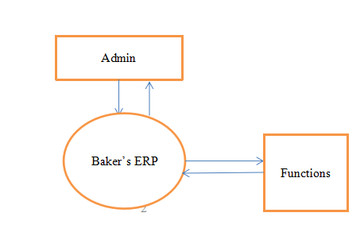

Chapter 2

# Introduction to Proposed System

* 1. **Introduction**

The overall description is given in this chapter.The Baker’s ERP is a new system that replaces the current manual management system.The modern ERP solutions are too complex and require a certain amount of learning,manual system require too much work,our system provides easy usage with very little work required .The system is expected to evolve over several releases. This system mainly consists of online web application, IOS and Android APP and in near future it will have a desktop app as well . This system aims to provide the manager to check and balance the bakery management online. It handles the administration Department, stock detail, Employee management.

As the system is web based so any device with web browser and internet connection will be able to access it.

**2.2 Project Background or Overview**

Our project is based on certain phases like: the ERP product features for making enterprise resource planning easier. It focuses on the company, the stakeholders and applications, which allow for online management, distribution and collection of materials.

**2.3** **Project Description**

Manual work has a lot of disadvantages because a lot of data and record is lost due to manual working so ERP is basically the facility that keeps the record of whole department that is control by manager /owner of the company and our project focuses on the company, the stakeholders and applications, which allow for online management, distribution and collection of materials.

**2.4 Project objectives**

The objective of ERP system is to provide a solution for the Bakery to help in providing the concerned information to concerned users within the right time. For Admin it will help to find the stock detail,managing the employees,their records,salary and all the working of bakery.Whole system will be control by only Admins.

**2.5 Project Scope**

This type of project is Already been created before but the scope of our project is to pertains the ERP product features for making enterprise resource planning easier. Our system is more refined the modern ERP solutions are too complex and require a certain amount of learning,manual system require too much work,our system provides easy usage with very little work required .The system is expected to evolve over several releases. This system mainly consists of online web application, IOS and Android APP and in near future it will have a desktop app as well . It focuses on the company, the stakeholders and applications, which allow for online management, distribution and collection of materials.This project focuses on developing an Employee Resource Planning website which provides facility to the management of the bakery to manage everything digitally. This website works finding new ways to make management easy by providing all the Employee information, stock information and resource information. The management is really inefficient manually and the systems already available are too complex to learn. Our ERP system will provide easy functionality to the management personnel, guarantees efficiency and minimizes time wastage.

**2.6 Product Features**

|  |  |  |
| --- | --- | --- |
| **Feature no** | **Feature Name** | **Description** |
| F01 | Authentication. | This feature describe that only admins should be able to register the Records and detail only admin has authentication to enter some thing admin may be one or more |
| F02 | System Administration. | This feature describes that there should be an admin who manages this system by managing Employees and Records. |
| F03 | Notification and Alerts | Notification will be updated when admin enter something. |

**2.7Use Case Diagram**

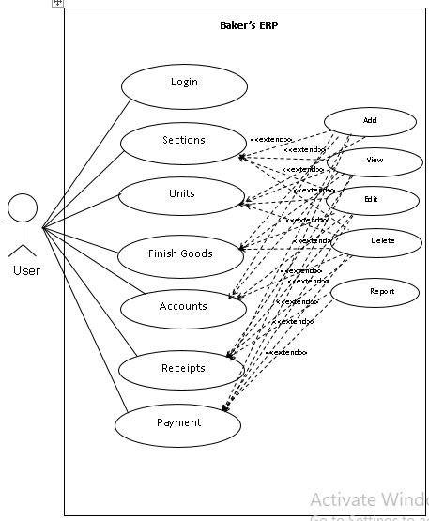

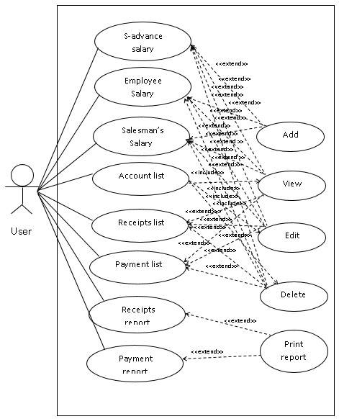

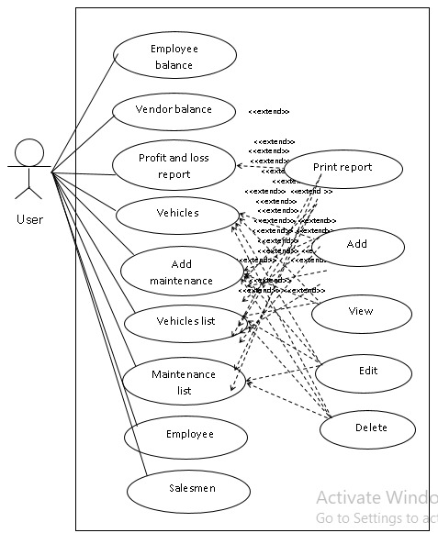

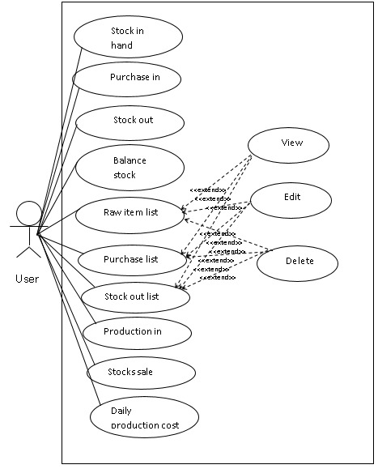

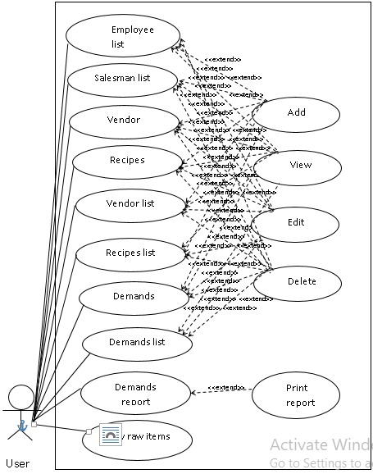

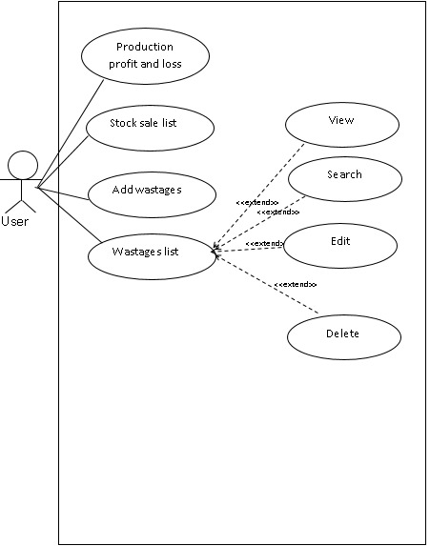

# Chapter 3

# Software Requirement Specification

2. 1. **Introduction**

In this chapter the system requirements and Specification of the project are described in detail with their fully dressed use cases and all non-functional requirements.It also include some important diagrams .

## 3.2 Functional Requirements

Functional Requirements Table

|  |  |  |  |  |
| --- | --- | --- | --- | --- |
| Feature Number | Title | Description | Stimulus/Response Sequence | Requirements |
| **Ft001** | Log IN | The user has to login with the given username and password to access the system. | The user inputs username and password.  The user clicks on LOGIN button.  If the password and username is correct then the user is redirected to the main dashboard. | Nil |
| **Ft002** | Dashboard | Main Screen will show total employees and total salesmen. Raw material stock alert will also be available on this page. | The user selects the dashboard option from side menu. | The user is logged in.  The user has the permission to use this function. |
| **Ft003** | Roles | Edit or remove user permissions. | The user selects the Roles option from side menu under Management. | The user is logged in.  The user has the permission to use this function. |
| **Ft004** | Users | Create new, Edit or delete users. | The user selects the Users option from side menu under Management. | The user is logged in.  The user has the permission to use this function. |
| **Ft005** | Options | User can add required key, value and description. E.g tray price, gas bill etc. | The user selects this option from side menu under Management. | The user is logged in.  The user has the permission to use this function. |
| **Ft006** | Add Sections | Add a new section to the database. | The user selects this option from side menu under Sections, Goods. | The user is logged in.  The user has the permission to use this function. |
| **Ft007** | Add  Units | Add a new unit to the database. | The user selects this option from side menu under Sections, Goods. | The user is logged in.  The user has the permission to use this function |
| **Ft008** | Add  Finish  Goods | Add a new finish good to the database. | The user selects this option from side menu under Sections, Goods. | The user is logged in.  The user has the permission to use this function. |
| **Ft009** | Sections  list | View and edit Sections. | The user selects this option from side menu under Sections, Goods. | The user is logged in.  The user has the permission to use this function. |
| **Ft010** | Units  List | View and edit units. | The user selects this option from side menu under Sections, Goods. | The user is logged in.  The user has the permission to use this function. |
| **Ft011** | Finish  Goods  List | View and edit Finish good. | The user selects this option from side menu under Sections, Goods. | The user is logged in.  The user has the permission to use this function. |
| **Ft012** | Create  Account | User can Create an account. | The user selects this option from side menu under Accounts, Day book. | The user is logged in.  The user has the permission to use this function |
| **Ft013** | Create  Receipt | Create a receipt. | The user selects this option from side menu under Accounts, Day book. | The user is logged in.  The user has the permission to use this function. |
| **Ft014** | Create  Payment | Create a payment. | The user selects this option from side menu under Accounts, Day book. | The user is logged in.  The user has the permission to use this function. |
| **Ft015** | Create   1. Advance   Salary | Create a Salesman’s Loan. | The user selects this option from side menu under Accounts, Day book. | The user is logged in.  The user has the permission to use this function. |
| **Ft016** | Create Employee  Salary | Create an employee’s salary. | The user selects this option from side menu under Accounts, Day book. | The user is logged in.  The user has the permission to use this function. |
| **Ft017** | Create  Salesman  Salary | Create a salesman’s salary. | The user selects this option from side menu under Accounts, Day book. | The user is logged in.  The user has the permission to use this function. |
| **Ft018** | Accounts  List | View, edit or delete accounts. | The user selects this option from side menu under Accounts, Day book. | The user is logged in.  The user has the permission to use this function. |
| **Ft019** | Receipts  List | View, edit or delete receipts. | The user selects this option from side menu under Accounts, Day book | The user is logged in.  The user has the permission to use this function |
| **Ft020** | Payments  List | View, edit or delete Payments. | The user selects this option from side menu under Accounts, Day book. | The user is logged in.  The user has the permission to use this function. |
| **Ft021** | 1. Advance Salary | View, edit or delete Employee’s advances/loans. | The user selects this option from side menu under Accounts, Day book. | The user is logged in.  The user has the permission to use this function. |
| **Ft022** | S-Advance Salary | View, edit or delete Salesman’s advances/loans. | The user selects this option from side menu under Accounts, Day book. | The user is logged in.  The user has the permission to use this function. |
| **Ft023** | Employee Salary | View, edit or delete Employee’s salary. | The user selects this option from side menu under Accounts, Day book. | The user is logged in.  The user has the permission to use this function. |
| **Ft024** | Salesman salary | View, edit or delete salesman salary. | The user selects this option from side menu under Accounts, Day book. | The user is logged in.  The user has the permission to use this function. |
| **Ft025** | Receipts Reports | System generates printable Receipt report. | The user selects this option from side menu under Accounts, Day book. | The user is logged in.  The user has the permission to use this function. |
| **Ft026** | Payment Report | System generates printable Payment report. | The user selects this option from side menu under Accounts, Day book. | The user is logged in.  The user has the permission to use this function. |
| **Ft027** | Employee Balance | System generates printable Employee balance report. | The user selects this option from side menu under Accounts, Day book. | The user is logged in.  The user has the permission to use this function. |
| **Ft028** | Vendor  Balance | System generates printable Vendor Balance Sheet. | The user selects this option from side menu under Accounts, Day book. | The user is logged in.  The user has the permission to use this function. |
| **Ft029** | Profit And Loss Report | System generates printable Profit and Loss Report. | The user selects this option from side menu under Accounts, Day book. | The user is logged in.  The user has the permission to use this function. |
| **Ft030** | Add Vehicle | Create new vehicle in the database. | The user selects this option from side menu under Vehicles. | The user is logged in.  The user has the permission to use this function. |
| **Ft031** | Add Maintenance | Create new maintenance of vehicle present in the database. | The user selects this option from side menu under Vehicles. | The user is logged in.  The user has the permission to use this function. |
| **Ft032** | Vehicle List | View, search, edit or delete vehicles | The user selects this option from side menu under vehicles. | The user is logged in.  The user has the permission to use this function. |
| **Ft033** | Maintenance List | View, edit, search or delete maintenance. | The user selects this option from side menu under vehicles. | The user is logged in.  The user has the permission to use this function. |
| **Ft034** | Create Employee | Add a new Employee in the database. | The user selects this option from side menu under Employee. | The user is logged in.  The user has the permission to use this function. |
| **Ft035** | Create Salesman | Add a new Employee in the database. | The user selects this option from side menu under Employee. | The user is logged in.  The user has the permission to use this function. |
| **Ft036** | Employee List | View, edit, search, print or delete Employees. | The user selects this option from side menu under Employee. | The user is logged in.  The user has the permission to use this function. |
| **Ft037** | Salesmen List | View, edit, print or delete salesman. | The user selects this option from side menu under Employee. | The user is logged in.  The user has the permission to use this function. |
| **Ft038** | Create Vendor | Add a new Vendor in the database. | The user selects this option from side menu under Vendors. | The user is logged in.  The user has the permission to use this function. |
| **Ft039** | Vendor List | View, edit, print, search or delete Vendor. | The user selects this option from side menu under Vendors. | The user is logged in.  The user has the permission to use this function. |
| **Ft040** | Create Recipes | Add a new Recipe in the database. | The user selects this option from side menu under Recipe. | The user is logged in.  The user has the permission to use this function. |
| **Ft041** | Recipes List | View, edit, print or delete Recipe. | The user selects this option from side menu under Recipe. | The user is logged in.  The user has the permission to use this function. |
| **Ft042** | Create Demands | Add a new Demand in the database. | The user selects this option from side menu under Demands. | The user is logged in.  The user has the permission to use this function. |
| **Ft043** | Demand List | View, edit, print or delete Demand. | The user selects this option from side menu under Demands. | The user is logged in.  The user has the permission to use this function. |
| **Ft044** | Demand Report | System generates printable Demand report. | The user selects this option from side menu under Demands. | The user is logged in.  The user has the permission to use this function. |
| **Ft045** | New Raw Items | Add a new raw item in the database. | The user selects this option from side menu under Store. | The user is logged in.  The user has the permission to use this function. |
| **Ft046** | Stock In Hand | View, edit, print or delete Stock in hand. | The user selects this option from side menu under Store. | The user is logged in.  The user has the permission to use this function. |
| **Ft047** | Purchases In | Add a new purchased item in the database. | The user selects this option from side menu under Store. | The user is logged in.  The user has the permission to use this function. |
| **Ft049** | Stock out | Add a new stocked out item in the database. | The user selects this option from side menu under Store. | The user is logged in.  The user has the permission to use this function. |
| **Ft050** | Balance Stock | View, search, edit, print, delete balance purchases. | The user selects this option from side menu under Store. | The user is logged in.  The user has the permission to use this function. |
| **Ft051** | Raw Items List | View, edit, print or delete Raw Items. | The user selects this option from side menu under Store. | The user is logged in.  The user has the permission to use this function. |
| **Ft052** | Purchases List | View, edit, print or delete Purchased Items. | The user selects this option from side menu under Store. | The user is logged in.  The user has the permission to use this function. |
| **Ft053** | Stock Out List | View, print or delete stocked out Items. | The user selects this option from side menu under Store. | The user is logged in.  The user has the permission to use this function. |
| **Ft054** | Production In | Add a new production item in the database. | The user selects this option from side menu under Dispatch. | The user is logged in.  The user has the permission to use this function. |
| **Ft055** | Stock Sale | Add a new stock sale in the database. | The user selects this option from side menu under Dispatch. | The user is logged in.  The user has the permission to use this function. |
| **Ft056** | Daily Production Cost | System generates a printable daily production cost report. | The user selects this option from side menu under Dispatch. | The user is logged in.  The user has the permission to use this function. |
| **Ft057** | Production vs Demand | System generates a printable Production and Demand report. | The user selects this option from side menu under Dispatch. | The user is logged in.  The user has the permission to use this function. |
| **F058** | Product Profit And Loss | System generates a printable Profit and loss report for each produced item. | The user selects this option from side menu under Dispatch. | The user is logged in.  The user has the permission to use this function. |
| **Ft059** | Production in List | View, edit, search, delete, print production ins. | The user selects this option from side menu under Dispatch. | The user is logged in.  The user has the permission to use this function. |
| **Ft060** | Stock Sale List | View, search, delete, print production ins. | The user selects this option from side menu under Dispatch. | The user is logged in.  The user has the permission to use this function. |
| **Ft061** | Add Wastage | Add a new Wastage item in the database. | The user selects this option from side menu under wastage. | The user is logged in.  The user has the permission to use this function. |
| **Ft062** | Wastage List | View, search, delete, print wastage items list. | The user selects this option from side menu under wastage. | The user is logged in.  The user has the permission to use this function. |

**3.3 Sequence Diagram**

Sequence Diagram

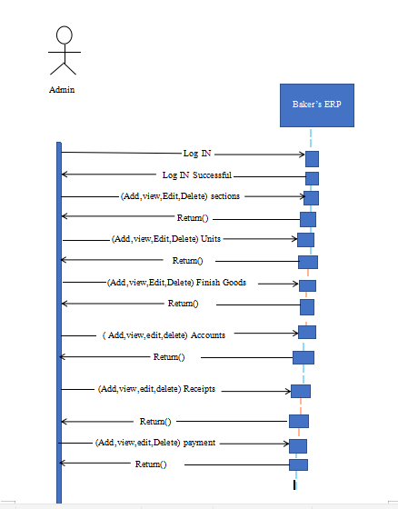

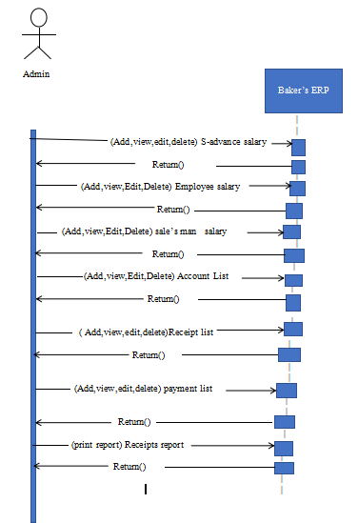

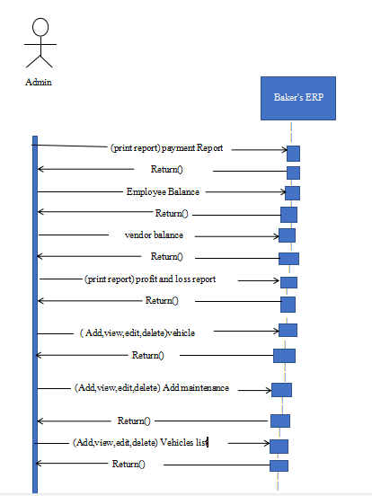

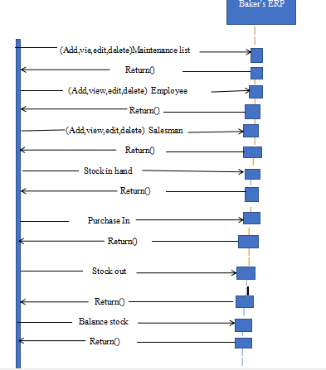

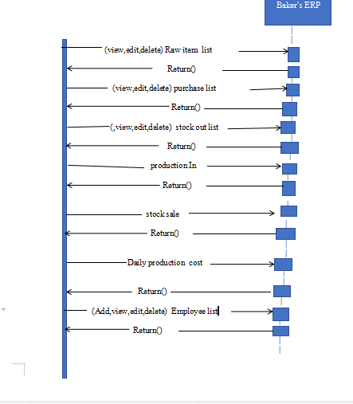

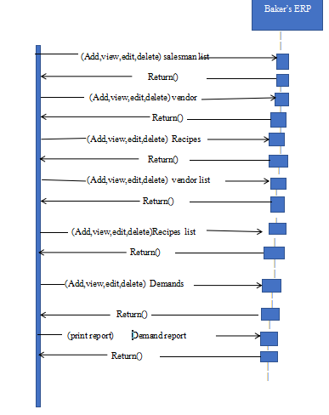

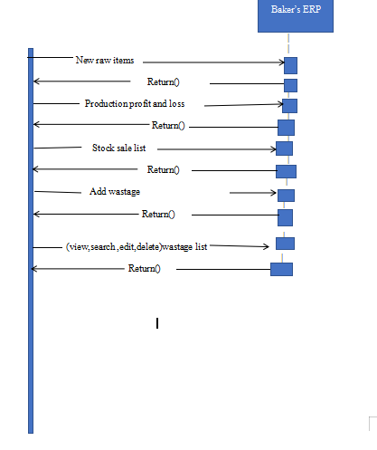

**3.4 Graphical User Interface**

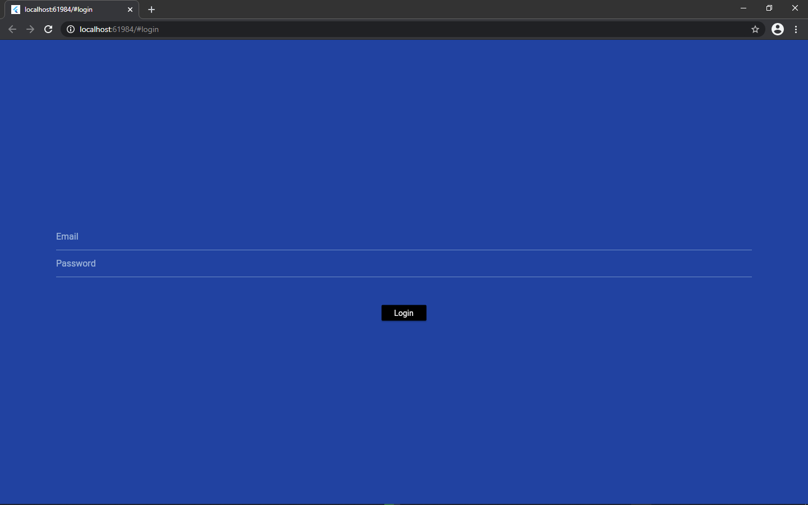

Log IN page through computer

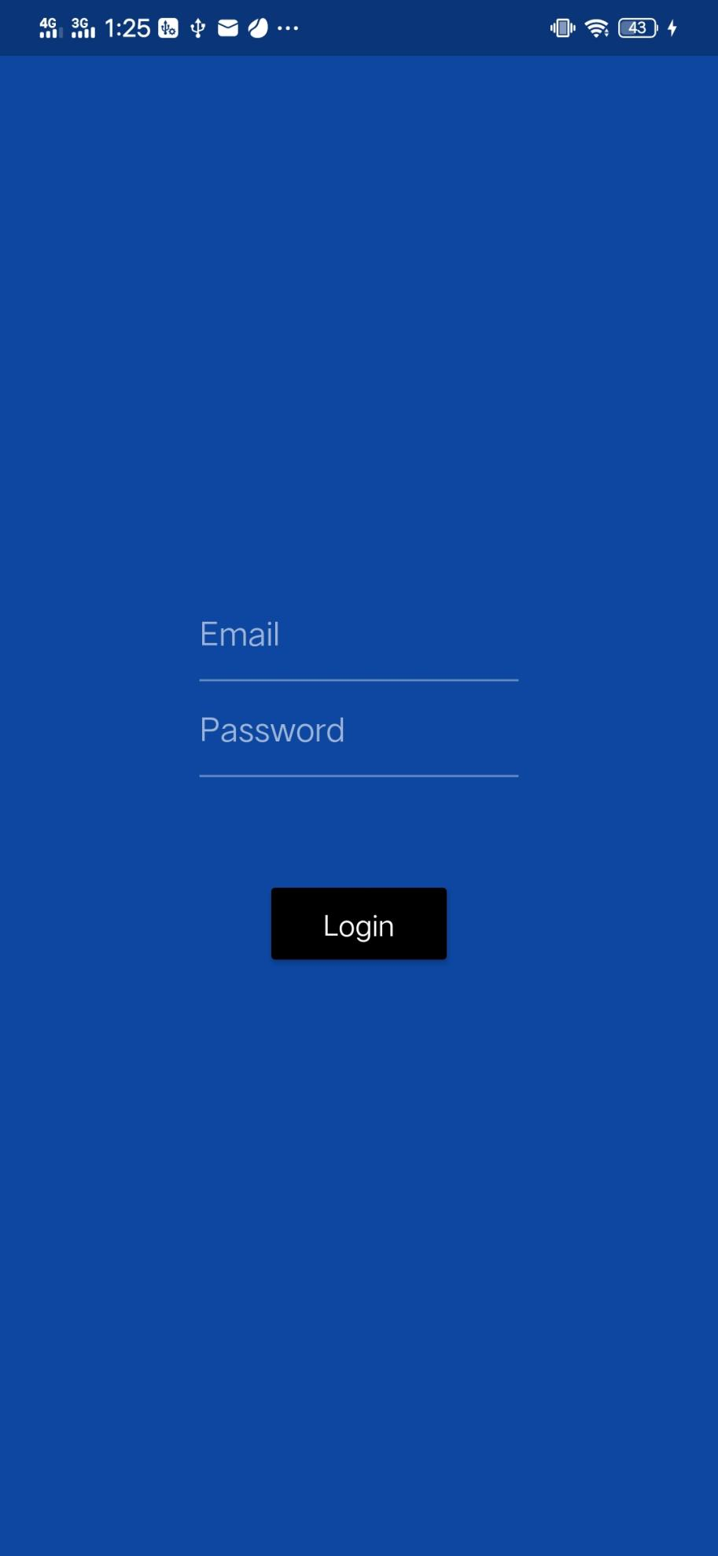

Log IN page with Mobile

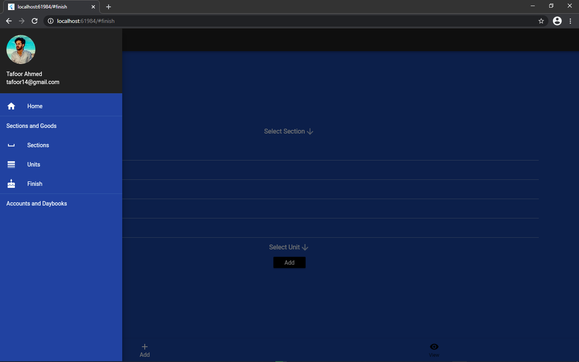

Section page with PC

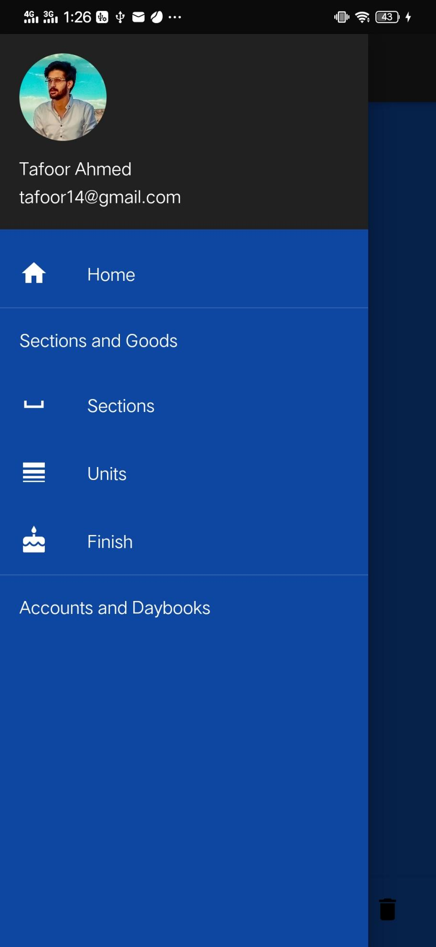

Section page with mobile

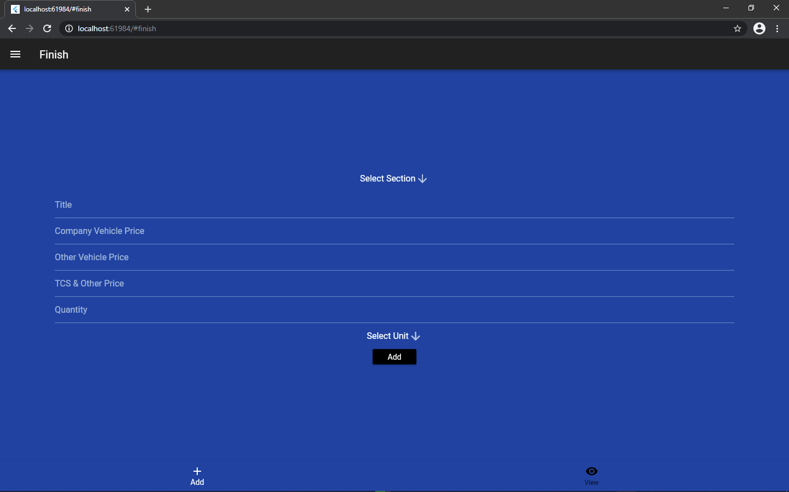

Data Table For Section

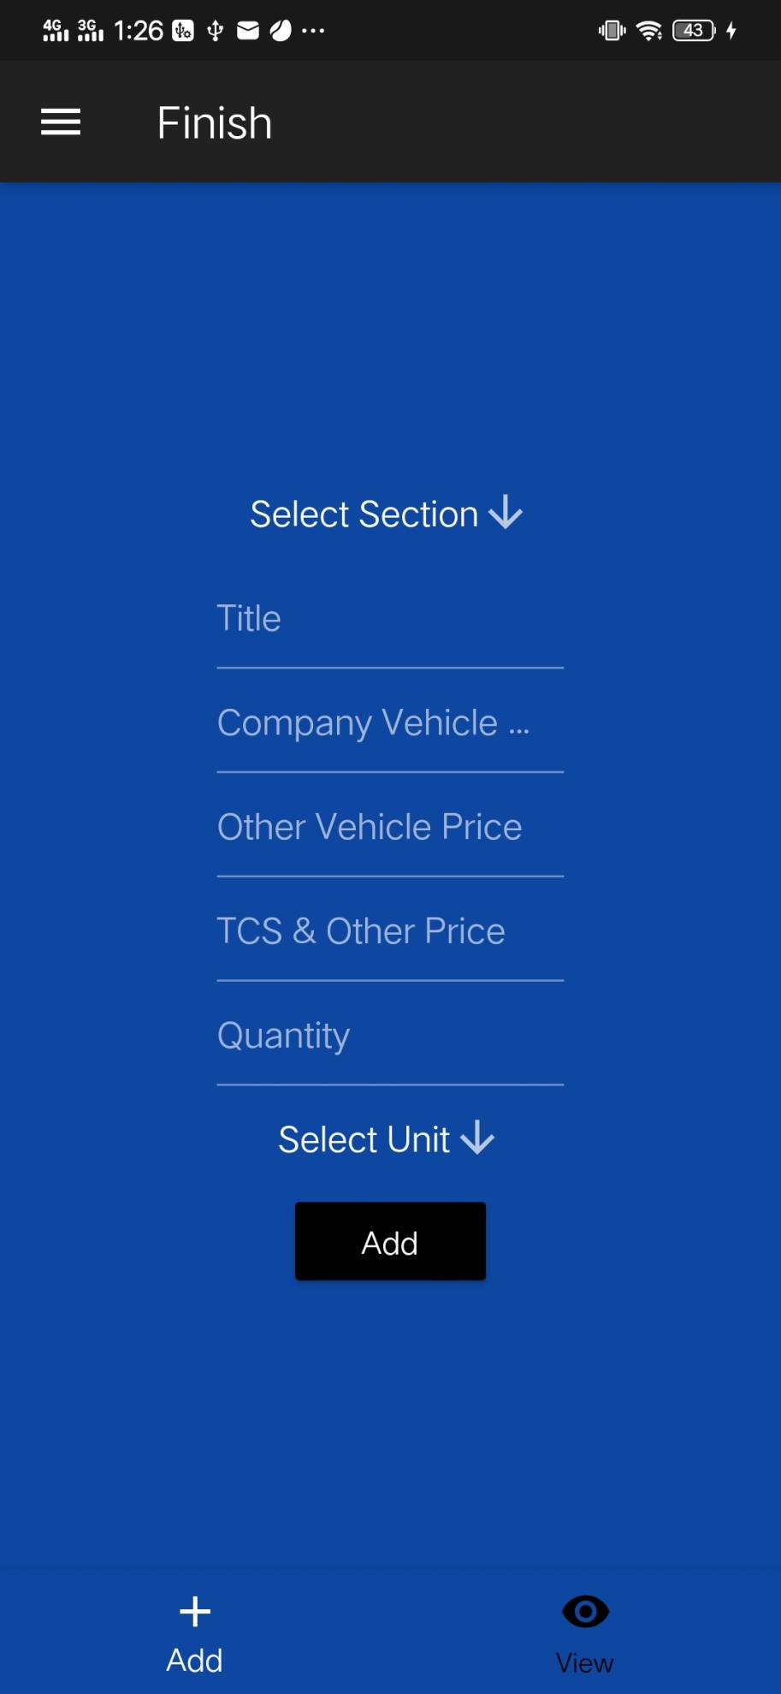

Data Table For Section on mobile

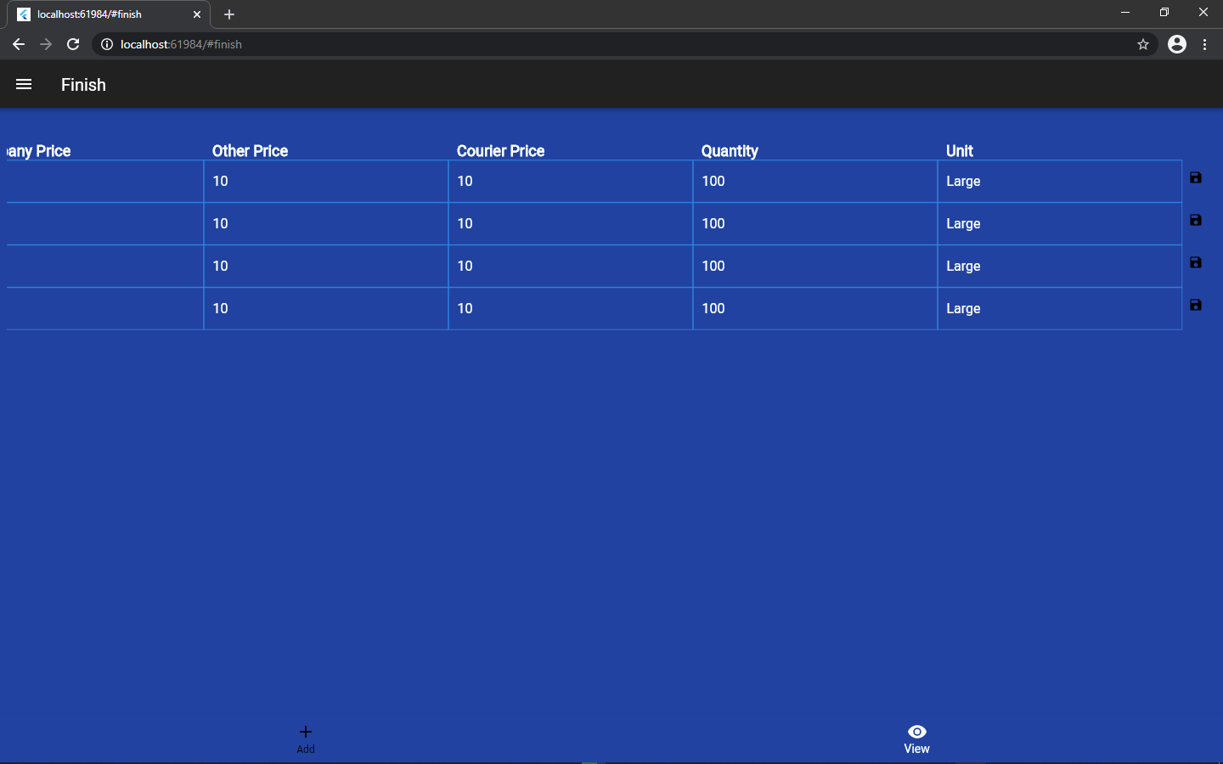

Data Table For Finish Goods on pc

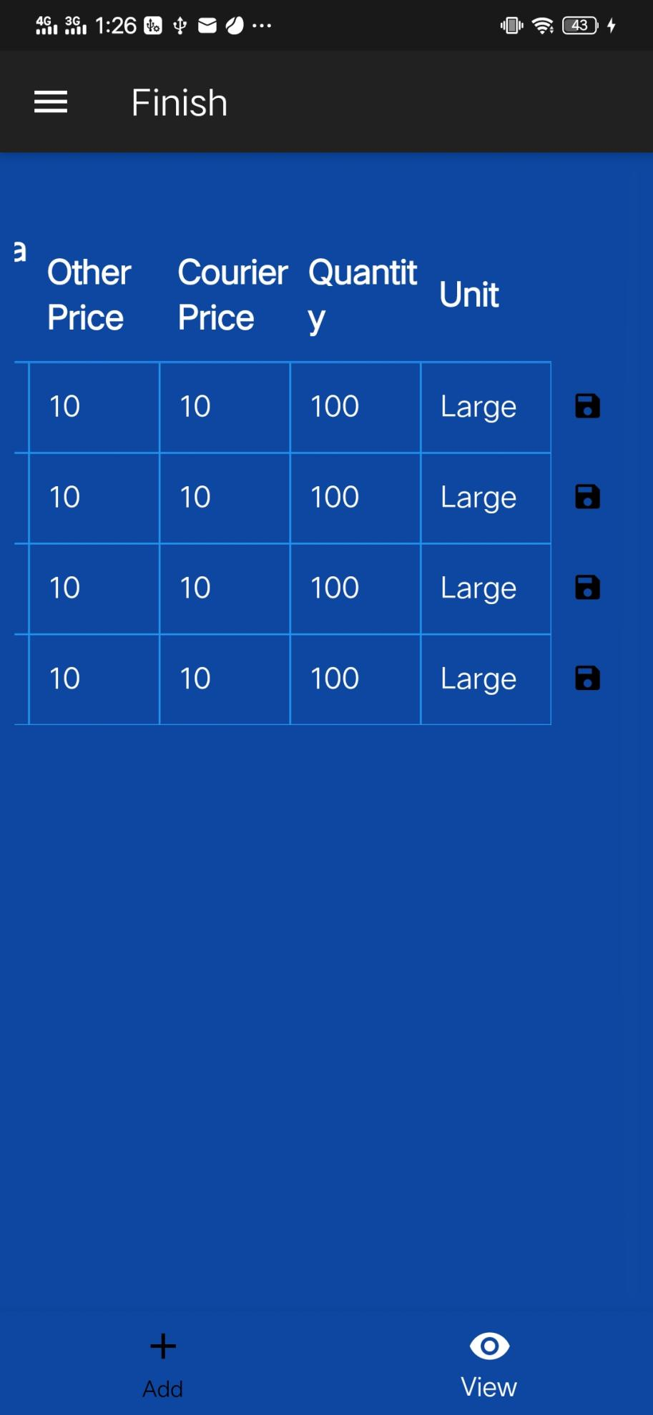

Data Table For finish goods on mobile

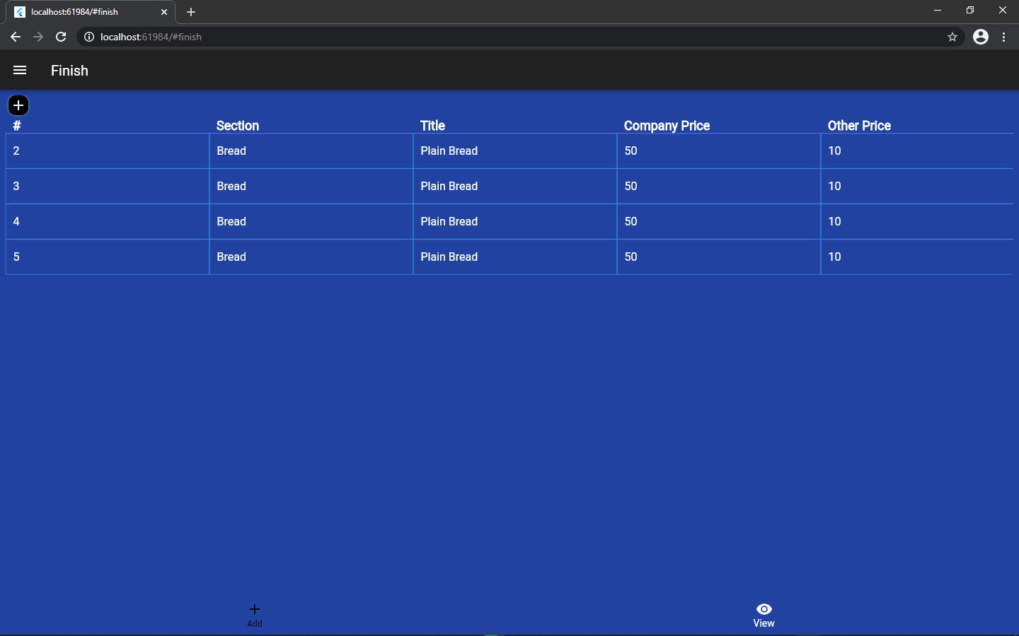

Computer

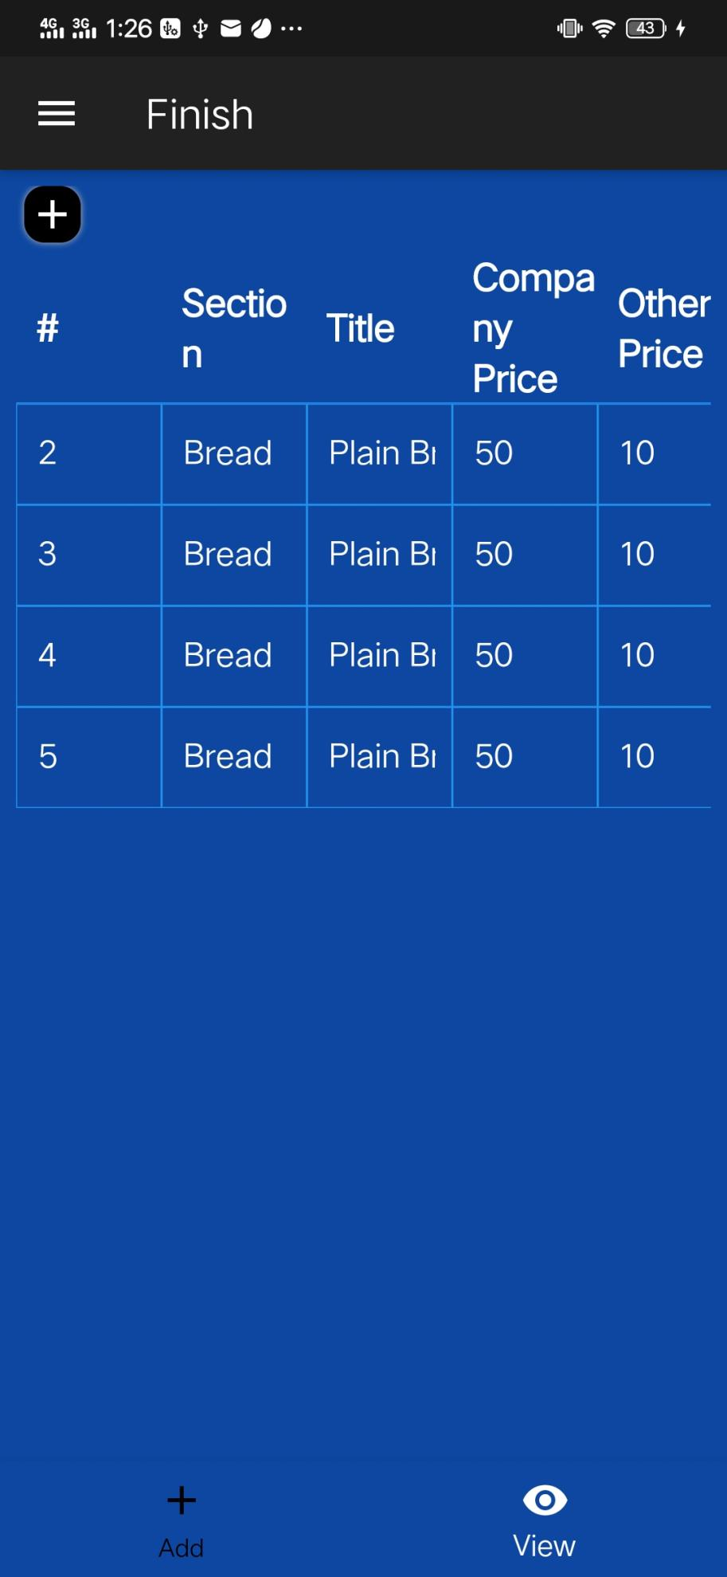

Mobile

**3.5 ERD**

**3.6 Non Functional Requirements**

|  |  |  |
| --- | --- | --- |
| **Requirement ID** | **Requirement name** | **Description** |
| NFR-01 | Availability | The Baker’s ERP System shall accommodate max 50-100 users during the peak usage time window of 8:00am to 02:00pm local time.s |
| NFR-02 | Response time | Responses to queries shall take no longer than 15 seconds to load onto the screen after the user submits the query. |
| NFR-03 | Adaptability | The Baker’s ERP System shall display confirmation messages to users within 6 seconds after the user submits information to the system |
| NFR-04 | Maintainability | Admin can maintain the records any time. |
| NFR-05 | Safety & Security | * The system shall protect the data of the user * The files generated by the system are only accessible by the admin and the users having the permission to do so. Application should store these files in Firebase database and must not share them. * Users must use all the content/data in the system as ordered, violation in terms of services may result in a ban of that account. * The server which the ERP web application uses will have its own security to prevent unauthorized write/delete access. * The system should provide a secure login to the users by using advanced secure login algorithms and provide access only to the authorized users as security is the key requirement of this system. * The user ID and the password should not be shared with anyone. |
| NFR-06 | Efficiency | * The Baker’s ERP System should generate policy with an accuracy of 99% |
| NFR-07 | Consistency | * Users should use the uploaded content for editing viewing and deleting purposes only*.* |

**3.7 Block Diagram**

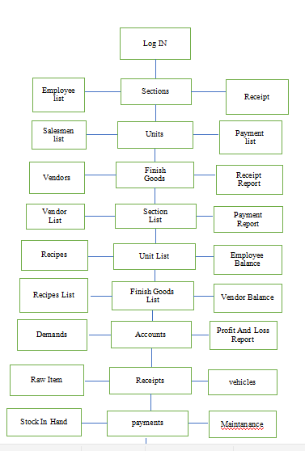

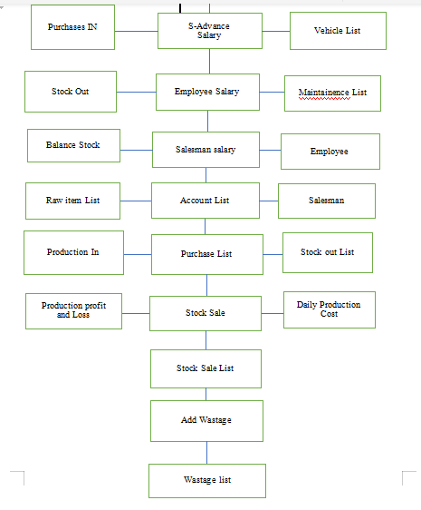

Chapter 4

# DESIGN SPECIFICATIONS

**4.1 Introduction**

In the design specification all the remaining deigns of the system is described. All the remaining models of the system is detailed described. The interaction models of the system are briefly described. The models contain the data flow models, sequence diagram, class diagram, deployment models all are described in this section.

**4.2 System Architecture Diagram**

The following figure shows the overall architecture and the actor with each action that will be processed in the system:

How system will do and perform all functionalities

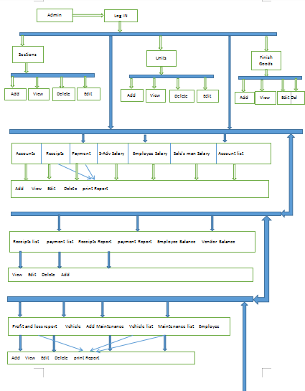

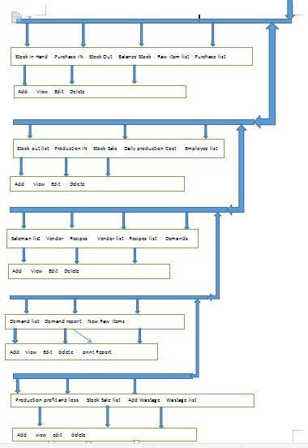

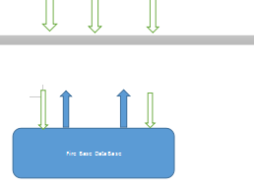

**4.3 High Level Design**

|  |  |  |
| --- | --- | --- |
| Serial  number | Constraints | Details |
| 1 | Hardware Limitation | Working internet  Every system with 2gb ram |
| 2 | Specific Technology | Flutter |
| 3 | Language Requirement | Flutter.Firebase |
| 4 | Programming Standard | No SQL |
| 5 | Tools | Visual studio code &  Firebase |

**4.7 Class Diagram**

